# CS 255 System Design Document Template

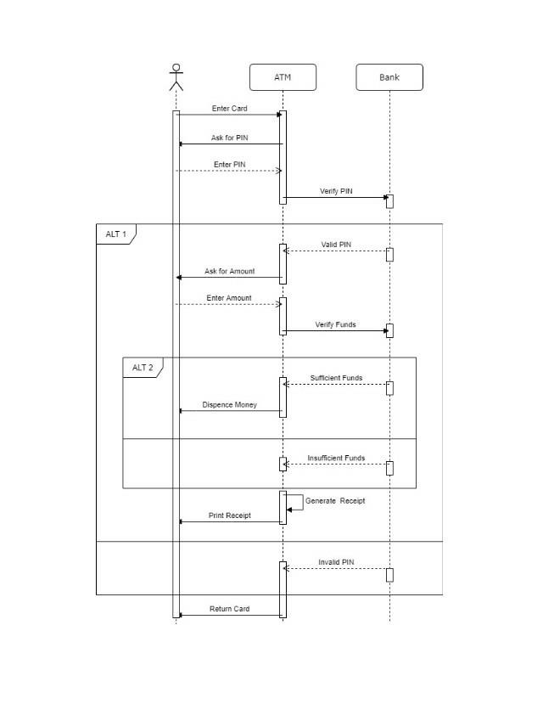

Insert ATM card

Get User Pin

Enter Pin

Validate User Pin

Pin Validation correct

Withdrawal Amount

Enter Amount

Verify Funds

Funds Available

Release Funds

Funds Unavailable

Receipt Print  
P

Ask user if Receipt is wanted

Pin validation Failed

Card Released

ALT 1

ALT 2

ATM

Bank

User

## UML Diagrams

### UML Use Case Diagram

### UML Activity Diagrams

*[You were asked to choose* ***two*** *use cases and create* ***two*** *activity diagrams, one for each use case. Please insert* ***both*** *of your activity diagrams here. Check to make sure that you included appropriate components and symbols and that your design meets the client’s needs.]*



### 

### UML Sequence Diagram

### UML Class Diagram

## Technical Requirements

*In order for the system to run smoothly we will want to create it to run on the web using the cloud for easier storage, pulling of information and to ensure it stays online and runs with minimal downtime. The system will also need to be able to run on a cell phone so a mobile version is required as well so there is easy access to download data. Since there will be a multitude of data to download and pull we will need a solid database whether that’s cloud based or a physical data center. The database will need to store login credentials, and other private information from users and the clients. In order to ensure privacy and security its best to have information transferred back and forth be encrypted SSL. This will be used for all data whether its data being shared in the database back and forth or during the download process. We will need information to update fast, when booking and scheduling appointments, tracking training progress, drivers comments on practice and appointment and test results, the best platform for this will be a cloud based on for minimal download time and speed.*

*Access will need to be given per role and job descriptions that way not everyone has the ability to delete and add users, change customer information or see progress and scores on trainings.*